# CS 340 README PROJECT TWO

Student: Hector Banos Ramos Date: 04/21/2024

## About the Project/Project Title

Project Title: Grazioso Salvare Web Application

This project, from the CS 340 course, aims to develop a web application dashboard for Grazioso Salvare, an international rescue-animal training company. The dashboard will allow Grazioso Salvare to interact with and visualize data from a MongoDB database provided by a non-profit agency, Austin Animal Center (AAC) that operates animal shelters in the region around Austin, Texas. The app also uses CRUD Python Module that was developed to manage and manipulate animal data and provides Create, Read, Update, and Delete (CRUD) operations for interacting with the AAC database.

## Motivation

## This project serves as a platform to test expertise in working with databases and manipulating data. By developing and maintaining this CRUD Python module, users can enhance their proficiency with MongoDB and Python, which are essential skills for software development and data management. The project also provides an opportunity to practice building interactive web applications using the Dash framework, thereby enhancing skills in web development and data visualization.

## Required Functionality

* The dashboard includes the following components:
* Interactive filter options to filter the Austin Animal Center Outcomes data set by:
  + Water Rescue
  + Mountain or Wilderness Rescue
  + Disaster Rescue or Individual Tracking
  + Reset (returns all widgets to their original, unfiltered state)
* A data table that dynamically responds to the filtering options
* A geolocation chart
* A second chart (histogram) that dynamically responds to the filtering options

The dashboard should also include:

* The Grazioso Salvare logo with a URL anchor tag to the client's home page: www.snhu.edu
* A unique identifier containing the creator's name

## Getting Started

To start using CRUD Python Module, make sure you complete the following steps:

1. Import the CSV file aac_shelter_outcome.csv into MongoDB using the mongo import tool.
2. Create simple and complex indexes in MongoDB to optimize data retrieval.
3. Establish user authentication by creating an Admin account and an AAC user account for database access.
4. Verify that Python is installed on your system to execute the provided Python scripts and Jupiter Notebook files.

## Challenges Encountered During the Development of the CRUD Module and the User Account:

Some of the challenges I encountered were handling data insertion and retrieval efficiently, and setting up the **aacuser** account which were overcame, by using appropriate MongoDB queries and error handling in Python and following the instructions for creating accounts and giving permissions respectively.

## Installation

To use the CRUD Python Module, you need:

* To utilize the .py and .ipynb files, you'll need either **Python** or **Jupyter Notebook** installed. Python, renowned for its versatility, is useful in diverse fields such as web development, automation, and data analysis. You can get Python from the official website at Python.org.
* **MongoDB** to be able to access the database. MongoDB is a popular NoSQL database management system known for its flexibility and scalability. Make sure you have MongoDB installed on your machine or environment. You can download MongoDB from the official MongoDB website: MongoDB.com.
* Python files. The CRUD Python Module relies on the following files:
* **mylib.py:** This Python script contains the CRUD class definition, which encapsulates all CRUD operations (Create, Read, Update, Delete) for interacting with the MongoDB database. Ensure to place this file in your project directory.
* **testing_script.ipynb(optional)**: This Jupyter Notebook file contains the testing script for all CRUD functionalities. You can execute this script to test Create, Read, Update, and Delete operations of the CRUD module. Place this file in your project directory as well.
* Ensure you have the required Python libraries installed, including **pymongo**, this library allows Python applications to interact with MongoDB databases. Also, this Python driver for MongoDB offers support for various MongoDB operations such as CRUD operations (Create, Read, Update, Delete), aggregation pipelines, indexing, etc. **Pymongo** was chosen for this project due to its maturity, extensive documentation, and active community support. You can install pymongo by using this command: pip install pymongo.

## Attributes and Working Functionality of CRUD Operations

- Create: Inserts a new document into the specified MongoDB collection.

- Read: Queries for documents from the specified MongoDB collection based on provided criteria.

- Update: Modifies existing document(s) in the specified MongoDB collection based on provided criteria.

- Delete: Removes document(s) from the specified MongoDB collection based on provided criteria.

## Usage - Demonstration of the CRUD module’s functional operations

**CSV file import and execution to MongoDB**

Upload the Austin Animal Center Outcomes data set into your MongoDB by inserting a CSV file using the appropriate MongoDB import tool.

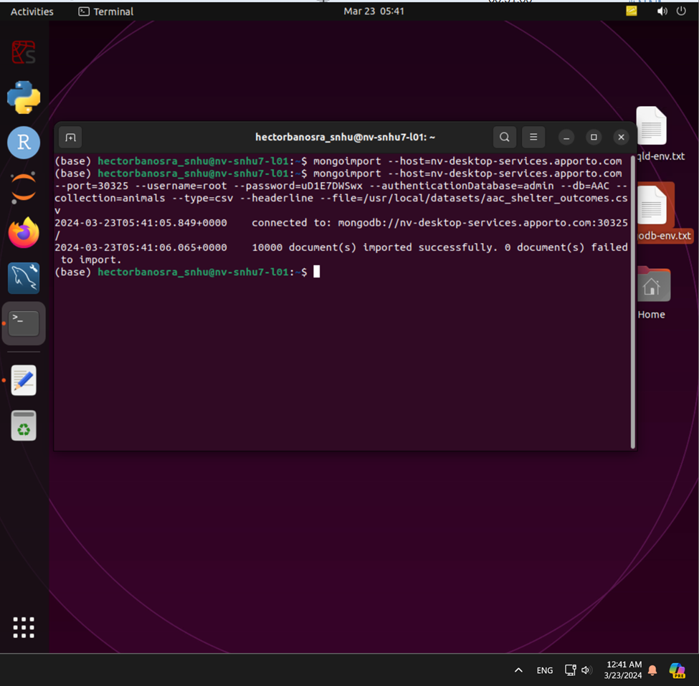

The CSV file and its database are running correctly.

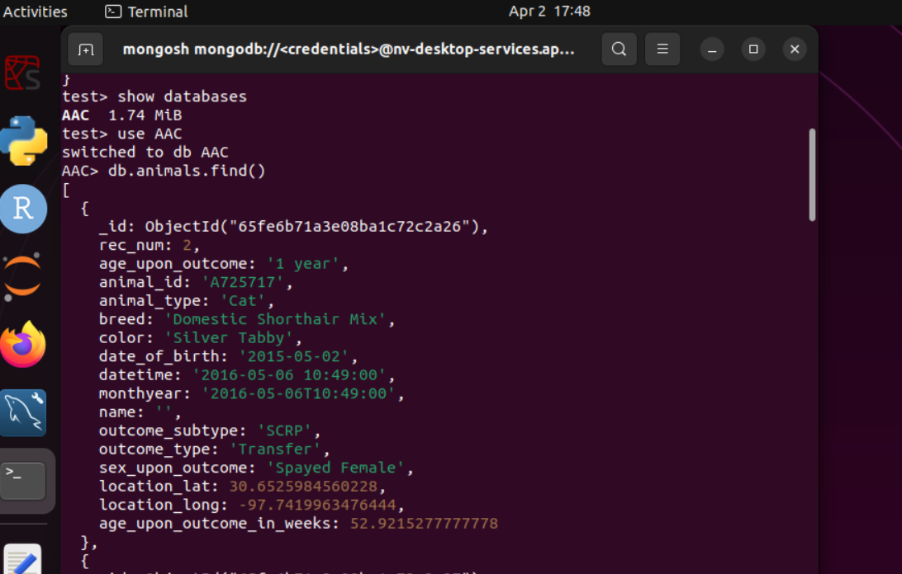

**User creation and authentication execution.**

Create a user account in the mongo shell to ensure user authentication to the database and collection you imported.

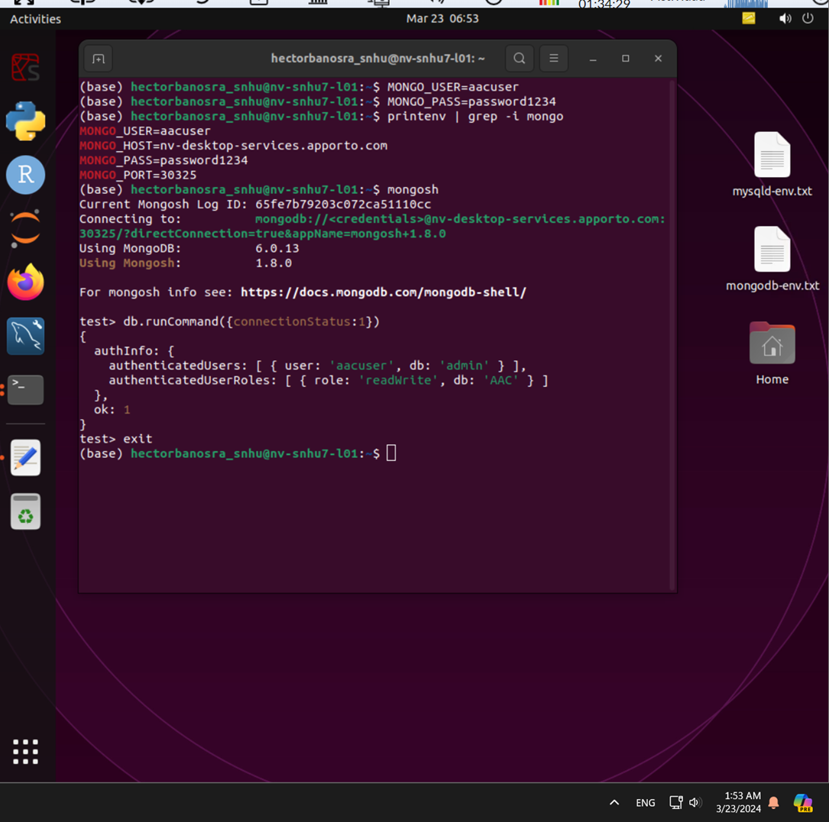

Connection to the MongoDB:

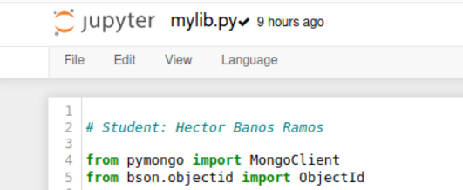

Note: The line from bson.objectid import ObjectId imports the ObjectId class from the bson.objectid module. The ObjectId class is used to generate unique identifiers (ObjectIDs) for documents in MongoDB.

User authentication:

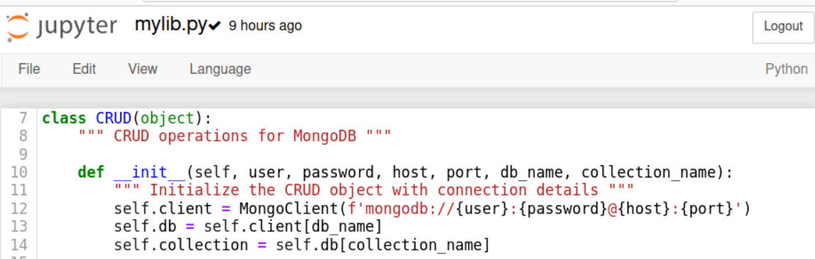

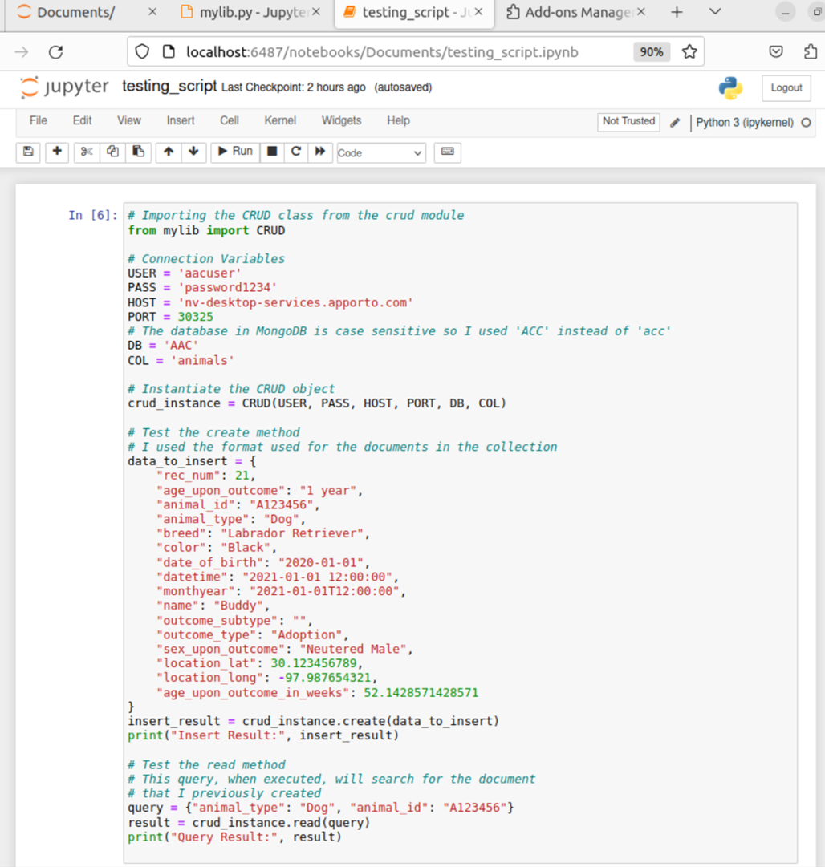

### Code Example and Screenshots - CRUD functionality test execution.

This version of CRUD Python Module provides essential functionality for managing animal data. Below is an example of how to use the module:

**mylib.py**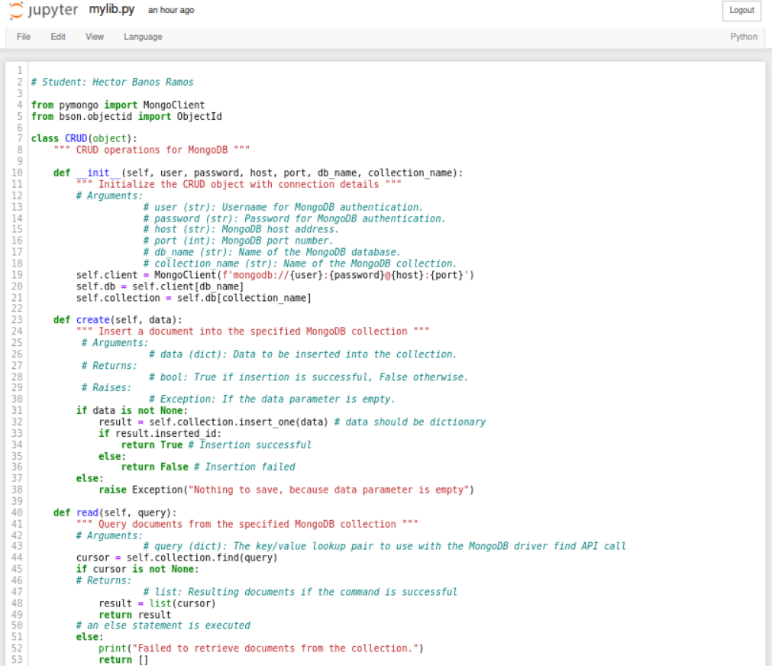

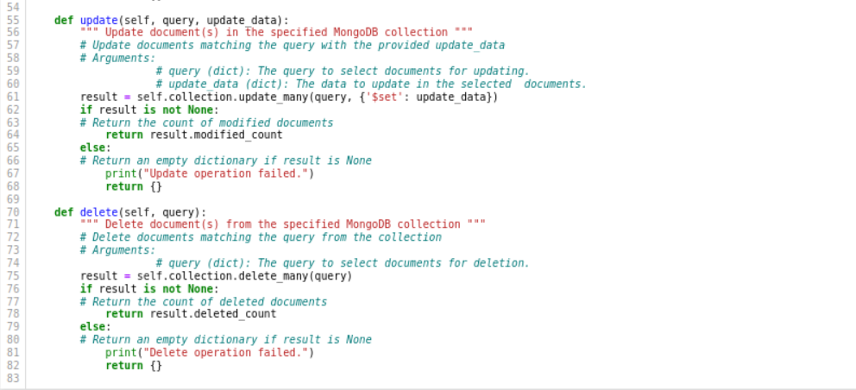

**How to use the CRUD python module:**

**Create Method:** Use the **create** method to insert a document into a specified MongoDB database and collection. Then provide a dictionary containing the data to be inserted. The method returns **True** if the insertion is successful, otherwise **False**.

**Read Method:** Utilize the read method to query for documents from a specified MongoDB database and collection. Provide a dictionary containing the key/value lookup pair to use with the MongoDB find API call. The method returns a list of resulting documents if the command is successful, otherwise an empty list.

**Update Method:** Employ the update method to query for and change documents from a specified MongoDB database and collection. Provide a dictionary containing the key/value lookup pair to use with the MongoDB find API call, and another dictionary containing the data to update.The method returns the number of objects modified in the collection.

**Delete Method:** Use the delete method to query for and remove documents from a specified MongoDB database and collection. Provide a dictionary containing the key/value lookup pair to use with the MongoDB find API call. The method returns the number of objects removed from the collection.

**testing_script.ipynb**

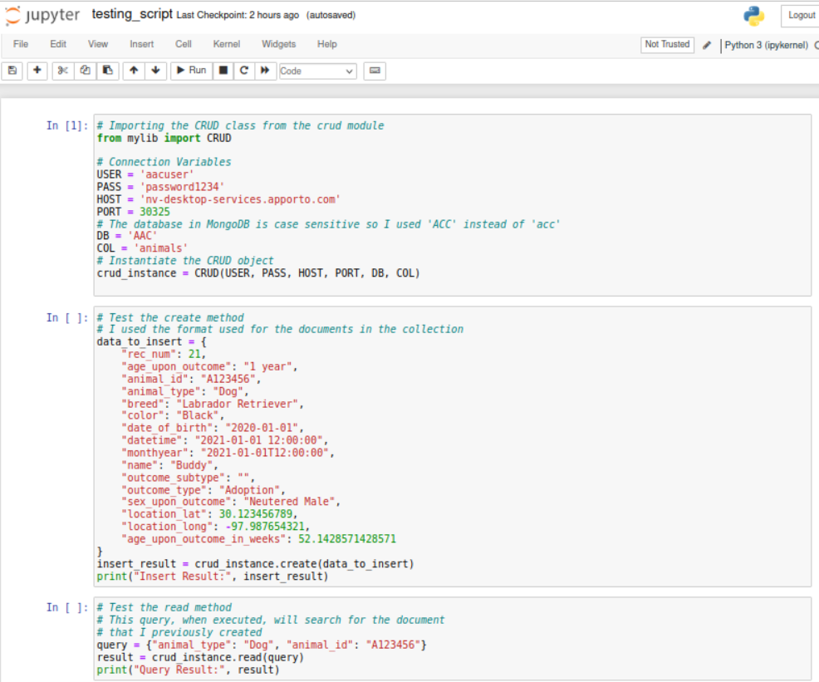

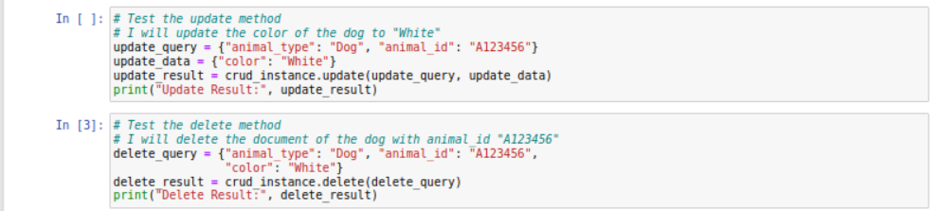

### Tests and Screenshots

The CRUD functionality has been tested using various scenarios. Below is an example of a valid test:

Testing the **creation** of an animal with **valid** data type:

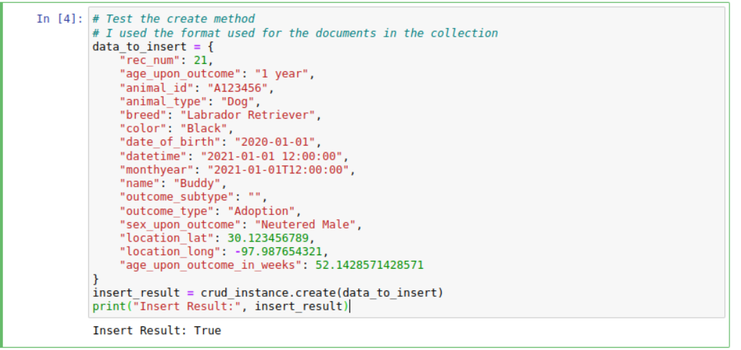

**Searching** for a specific animal whose collection was previously created: query = {"animal_type": "Dog", "animal_id": "A123456"}

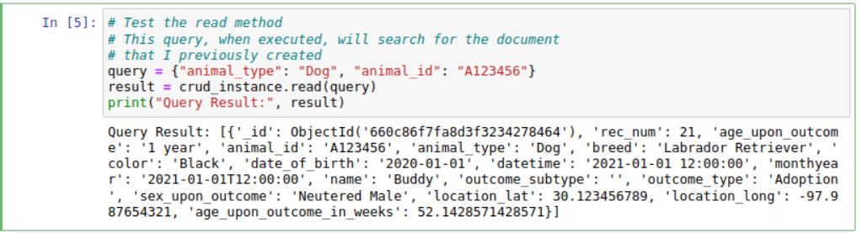

Testing the **update** of an animal document that was created previously:

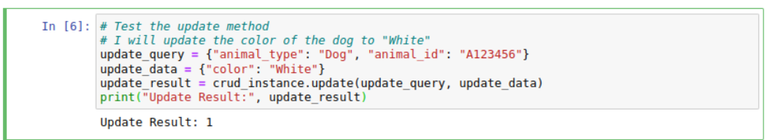

Testing the **delete** method of an animal document that was created previously:

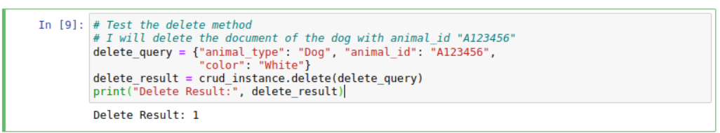

Testing the **creation** of an animal with **invalid** data type: data_to_insert = { 0:0}

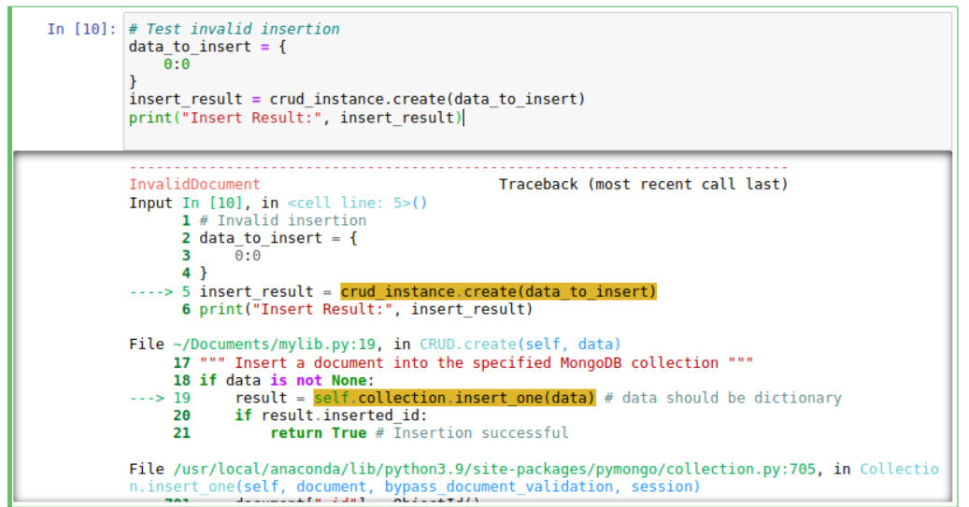

**Searching** for a specific animal(document) that doesn’t exist: query = {"animal_type": "Duck", "animal_id": "0000"}

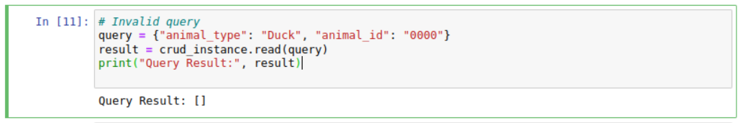

**Updating** a specific animal(document) that has the wrong animal ID: update_query = {"animal_type": "Dog", "animal_id": "A123457"}

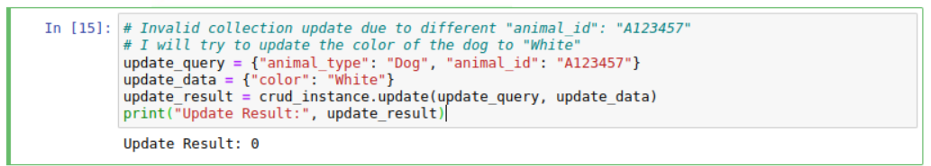

**Deleting** a specific animal(document) that has an invalid an argument: update_query = {"animal_type": "Dog", "animal_id": "A123457"}

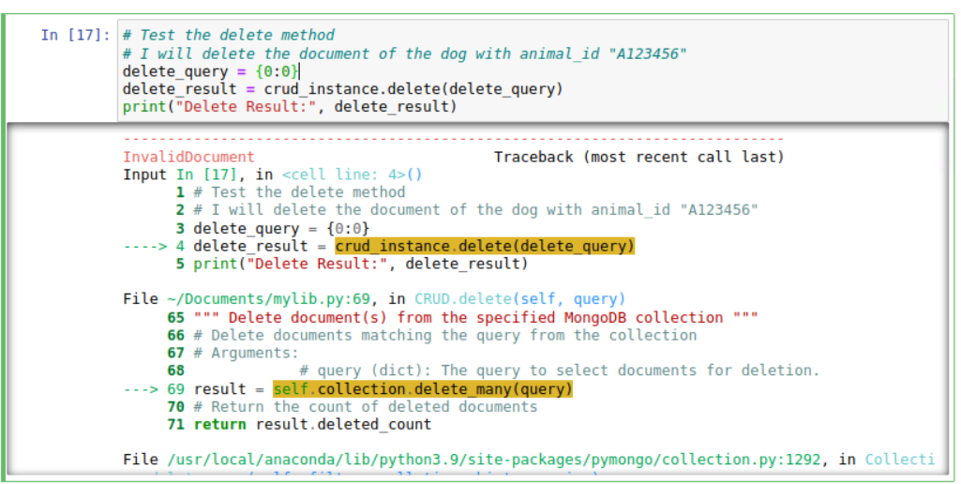

Invalid deletion results (the color of the animal was updated to white, so it fails on purpose):

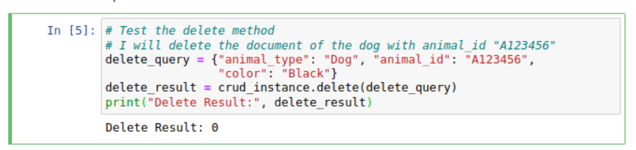

## Dash Framework source code:

## This is the code used to deploy the web application.

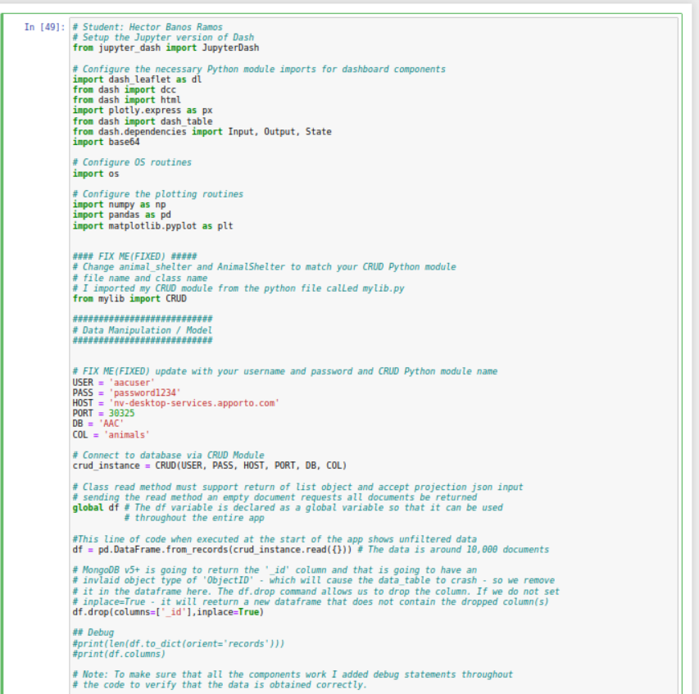

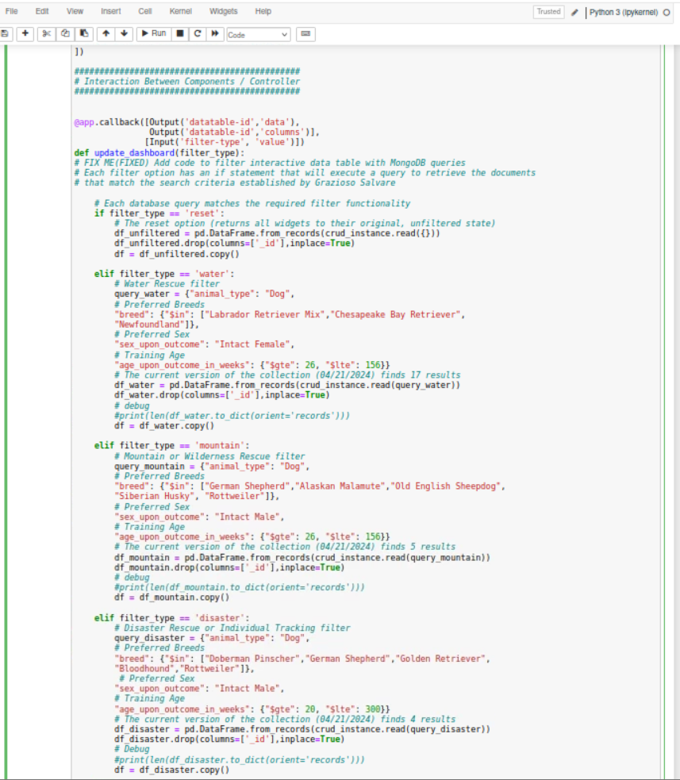

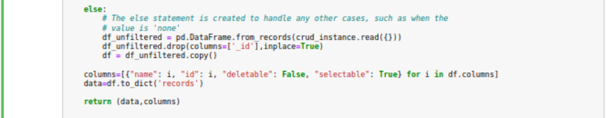

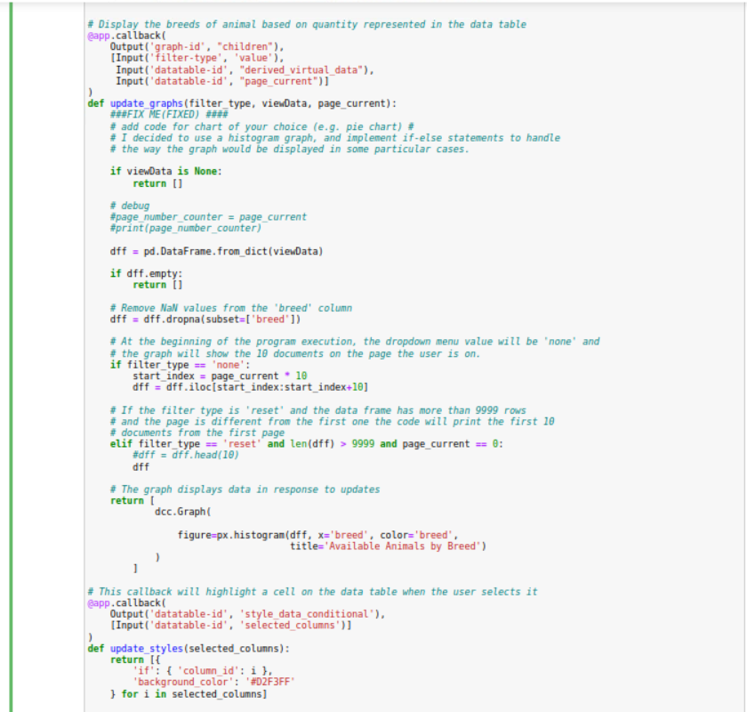

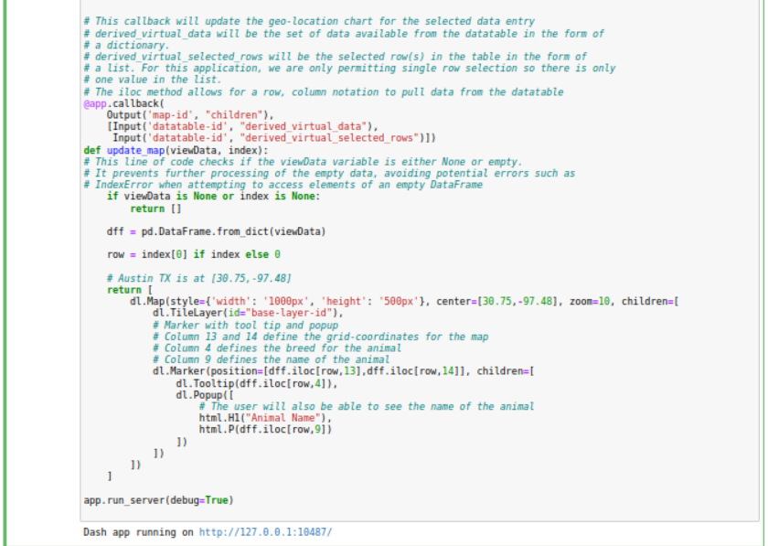

## Usage - Demonstration of the Dash framework and filtering options

This section includes screenshots and a screencast taken while testing and deploying your dashboard.

First execution of the web application:

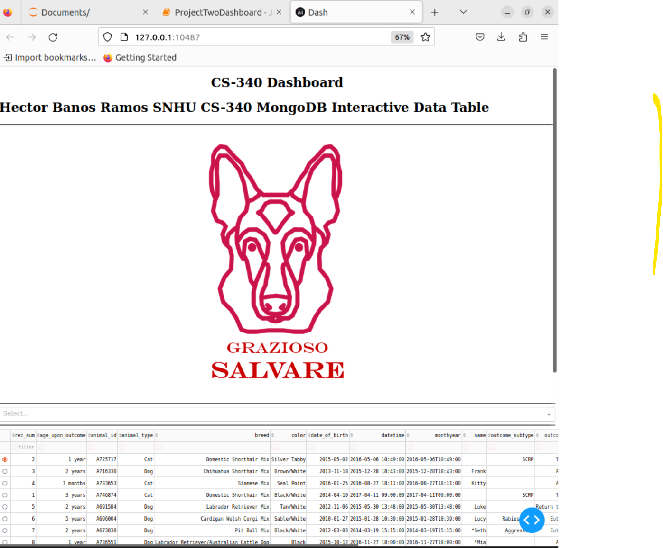

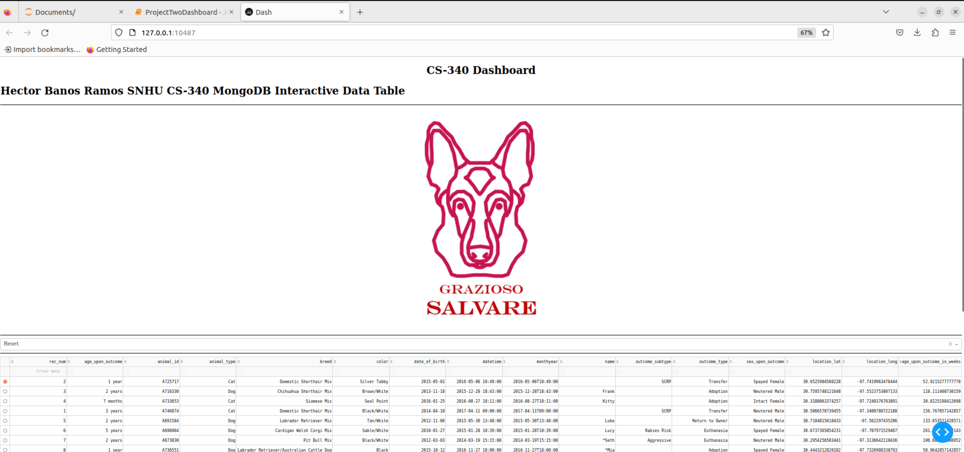

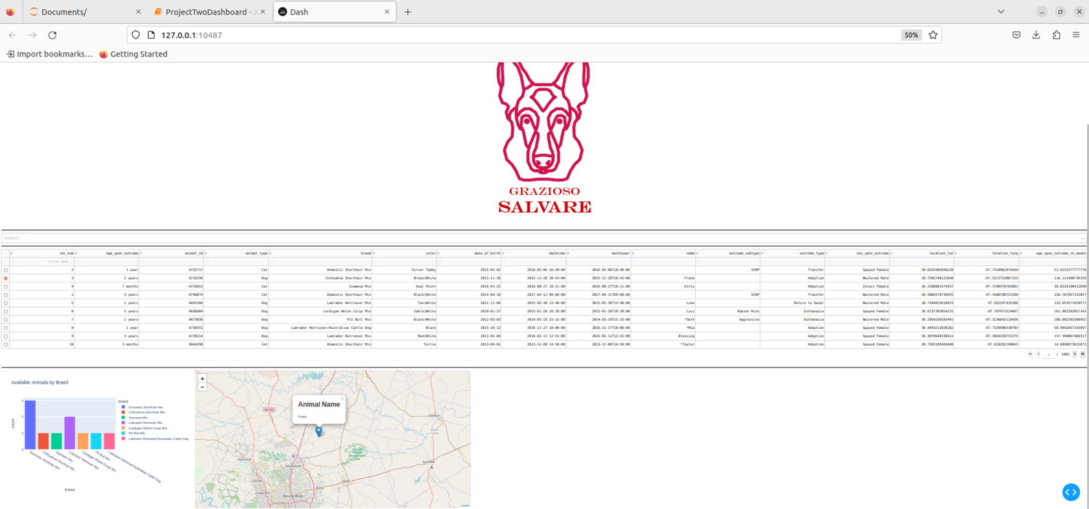

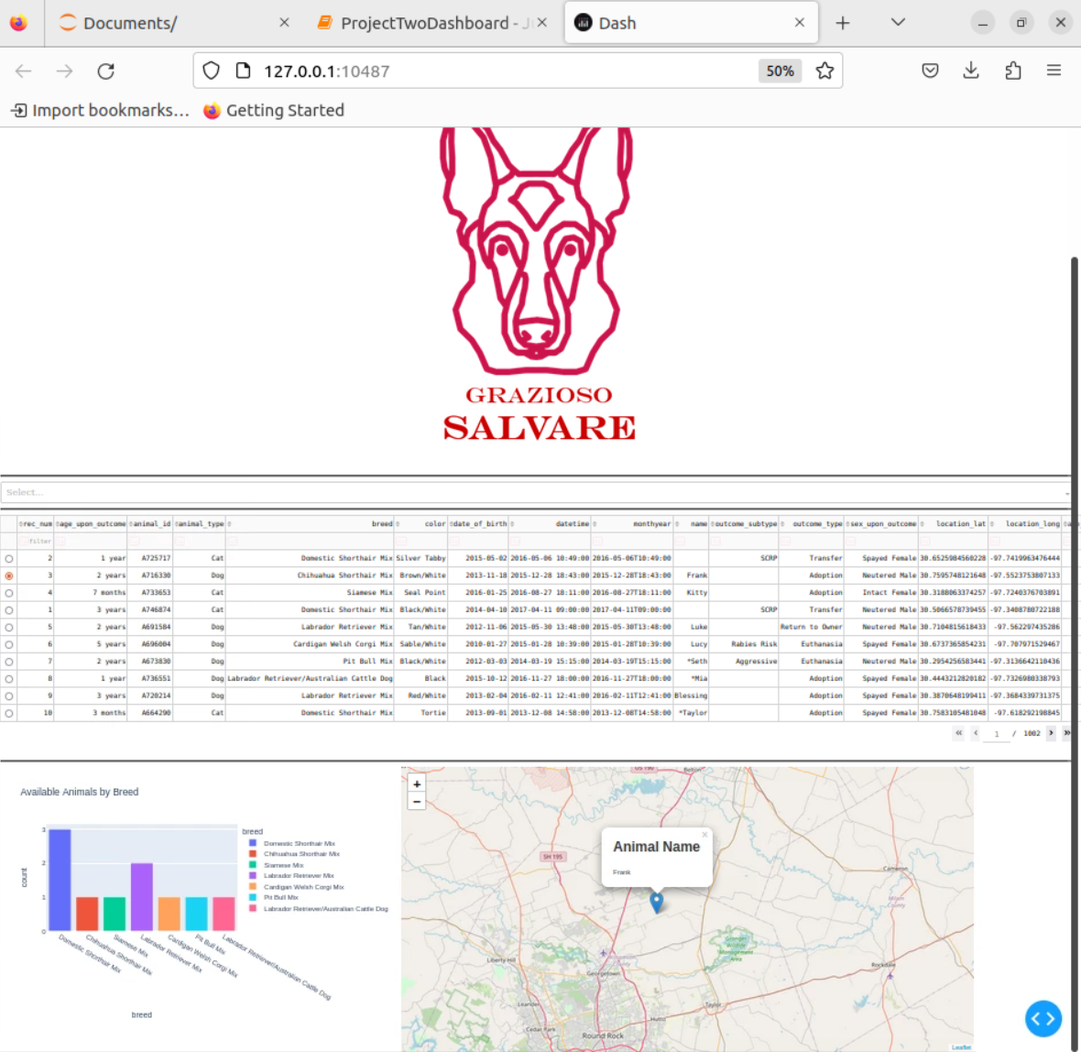

Selecting Water Rescue:

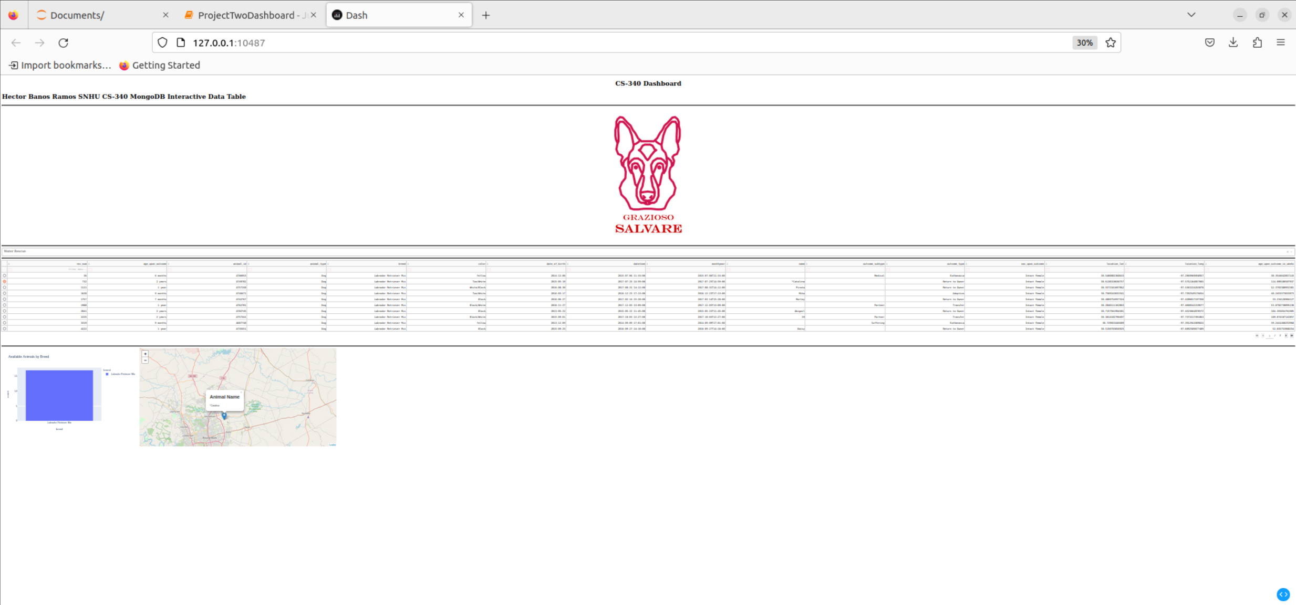

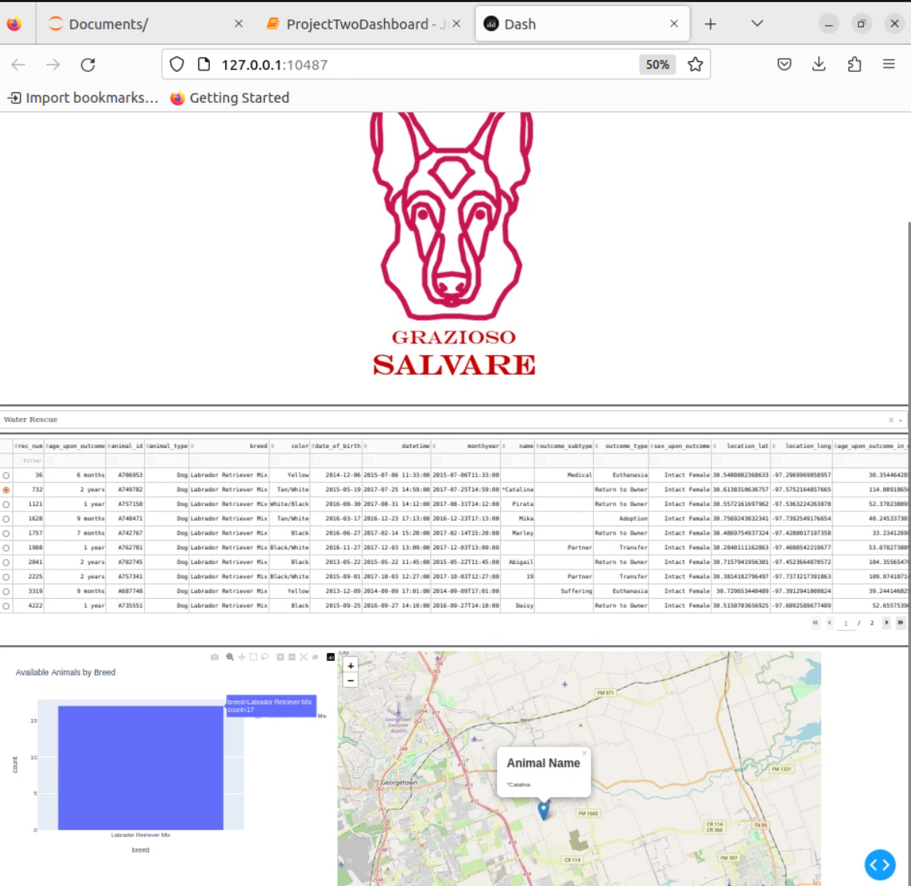

Selecting Mountain or Wilderness Rescue:

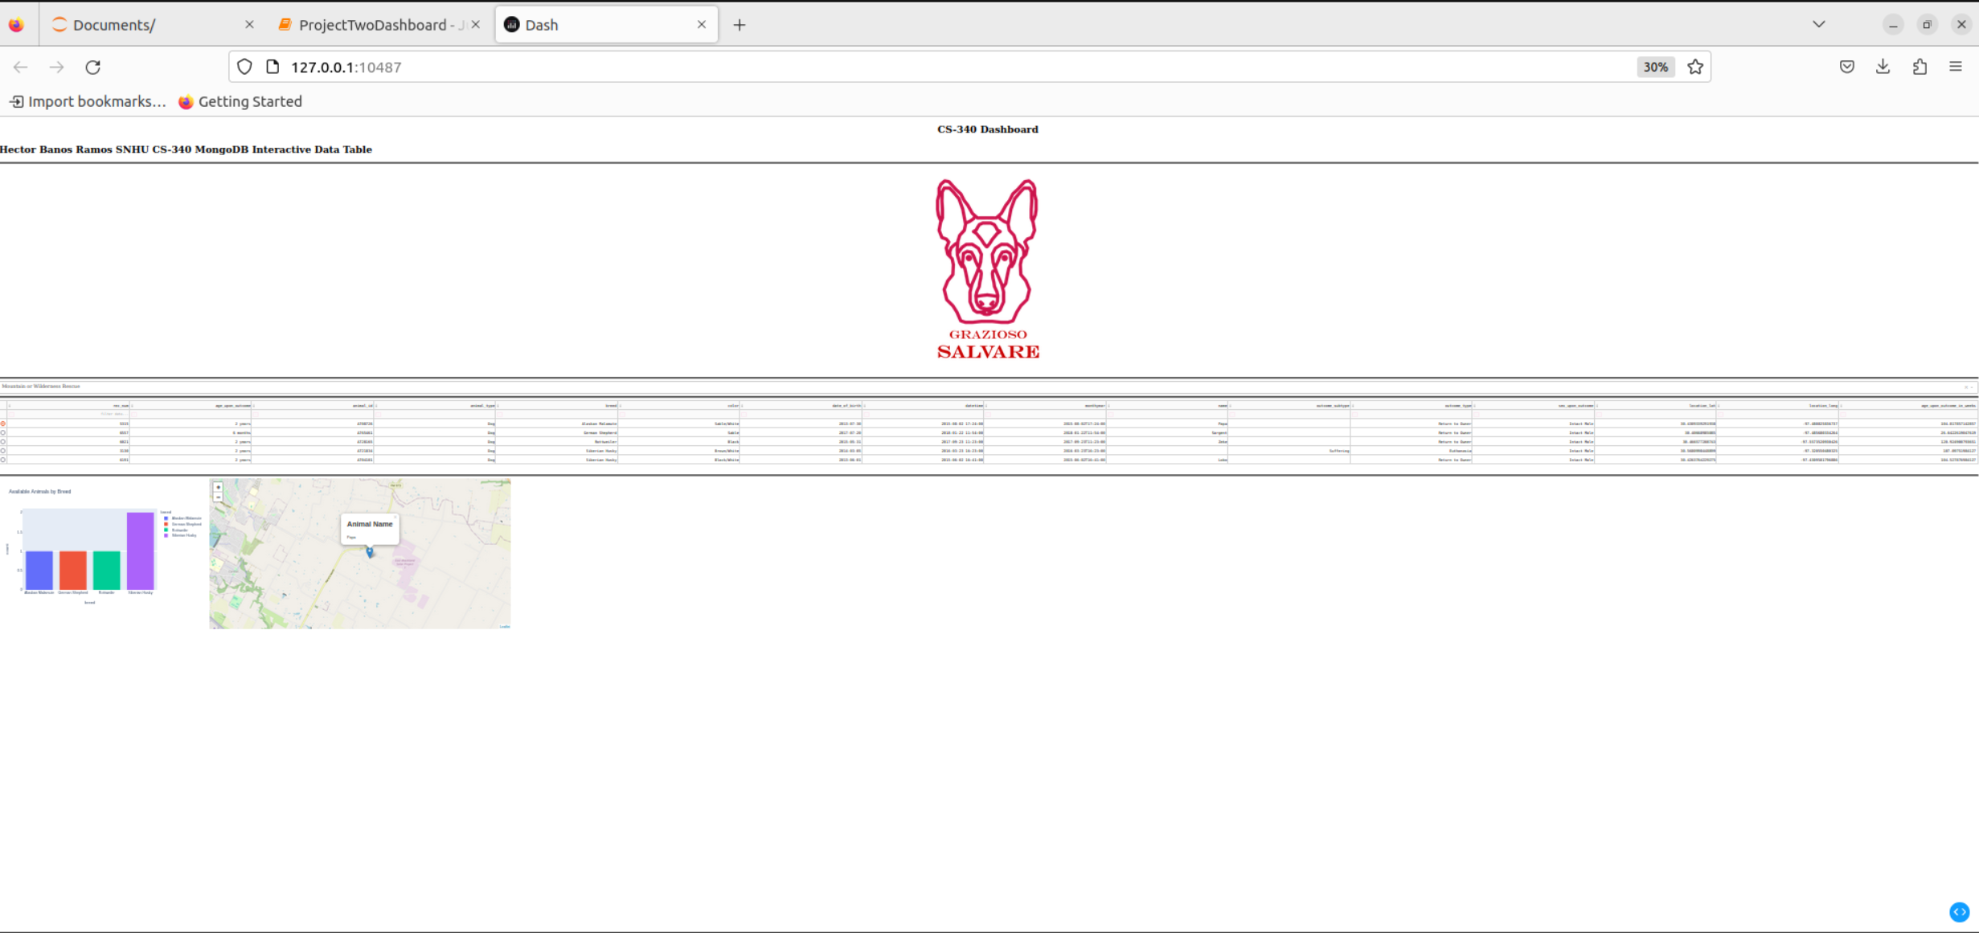

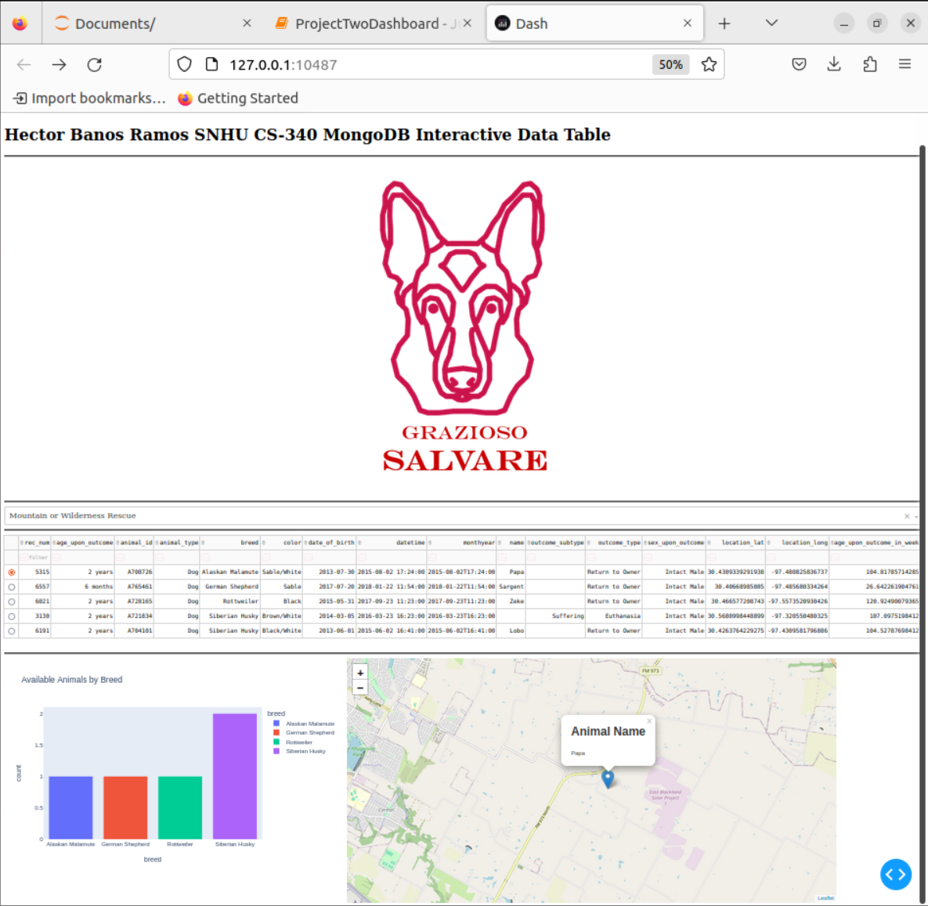

Selecting Disaster or Individual Tracking

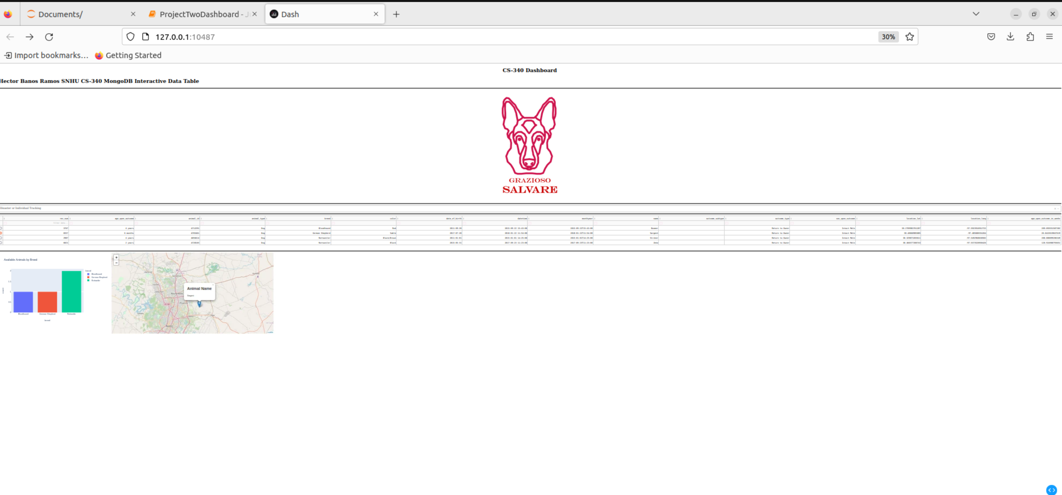

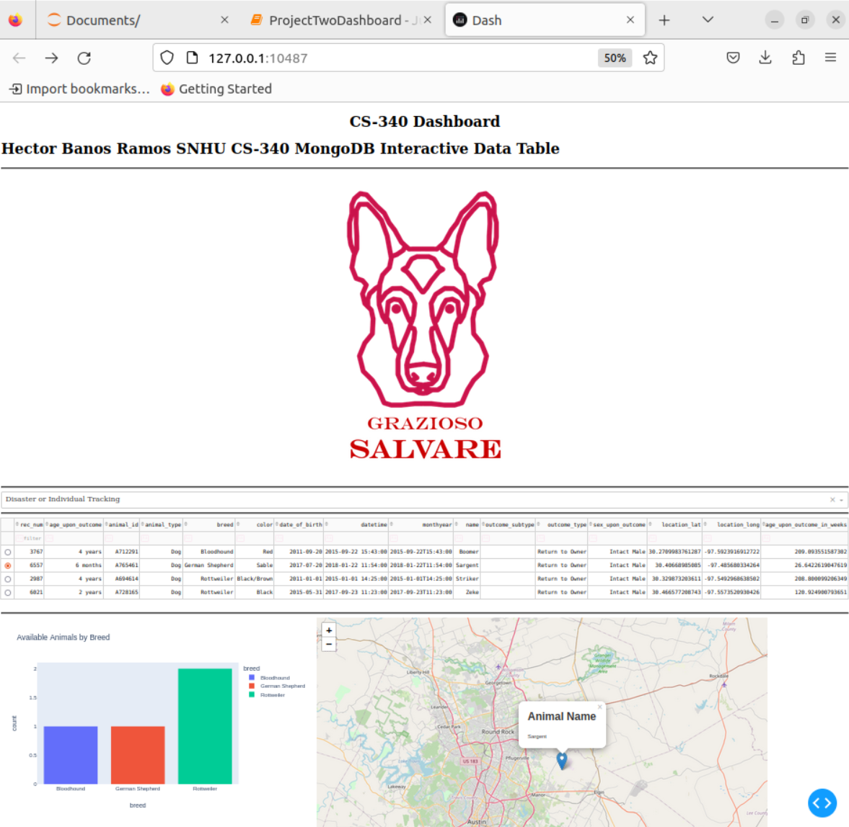

Reset (returns all widgets to their original, unfiltered state)

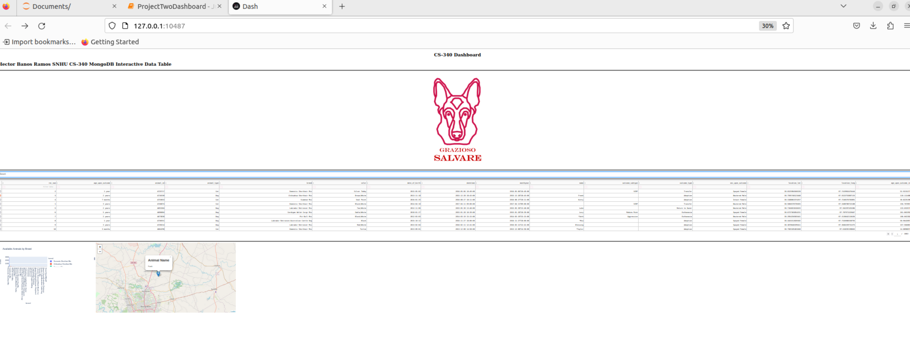

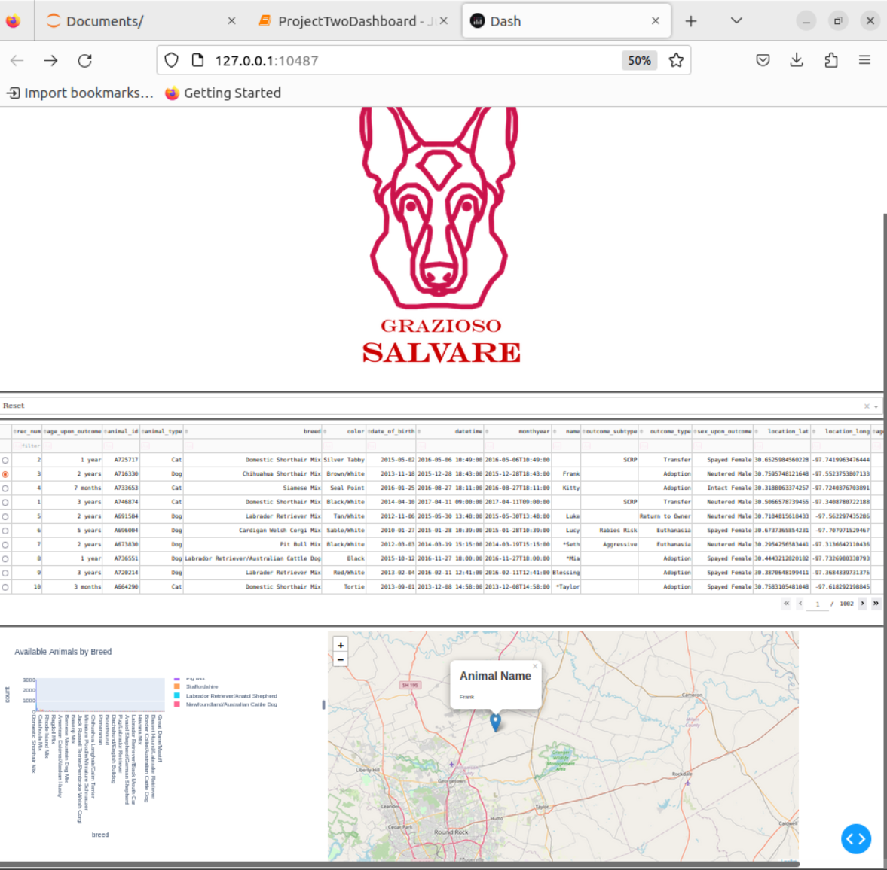

Testing the URL anchor tag to the client’s home page: www.snhu.edu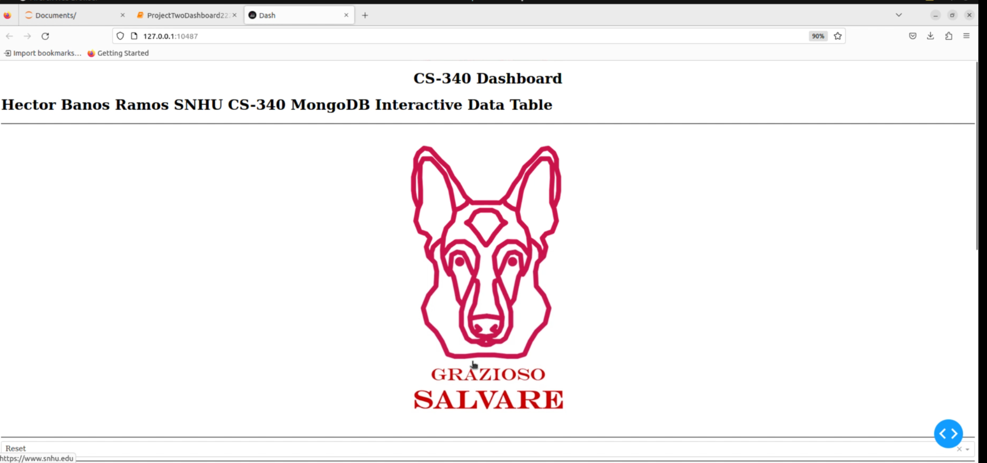

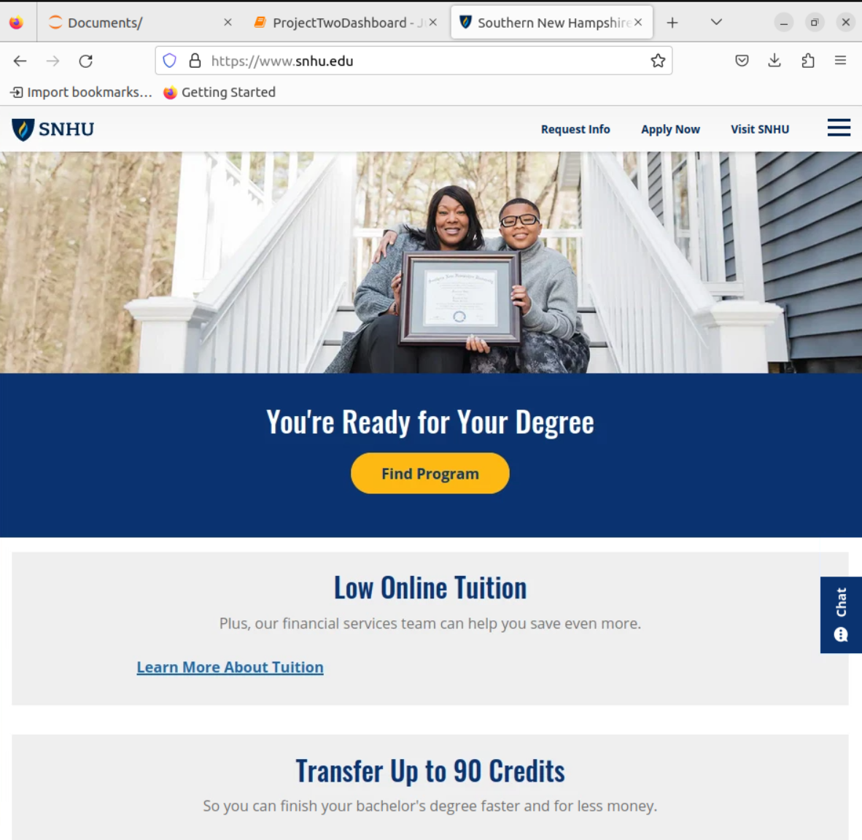

Screen recording testing the application (an account linked to SNHU is required):

[CS340_ProjectTwoDashboard_Screencast.mov](https://snhu-my.sharepoint.com/:v:/g/personal/hector_banosramos_snhu_edu/Eaf0UkxcJMhOmh_BquXs6nQBsqEOweiZw_553hhb6xAUsA?e=rmvMWx)

## Tools used to achieve the project functionality.

**Database:** MongoDB was chosen as the model component for the development due to the following reasons:

* MongoDB is a NoSQL database, offering flexibility and scalability.
* Its document-based model allows for easy integration with Python.

MongoDB's ability to store complex data structures makes it suitable for handling various types of data efficiently.

**Dash Framework**: Dash is a Python framework for building analytical web applications, was used to view and control the structure of the web application. Dash provides a user-friendly interface for building web applications using Python. It offers seamless integration with Pandas, Plotly, and other Python libraries for data visualization.

**Resources used:**

* [Dash User Guide](https://dash.plotly.com/)
* [Plotly Documentation](https://plotly.com/python/)
* [MongoDB Documentation](https://docs.mongodb.com/)
* [Jupyter Dash Documentation](https://github.com/plotly/jupyter-dash)
* [Base64 Documentation](https://docs.python.org/3/library/base64.html)
* [Austin Animal Center Outcomes Spreadsheet](https://learn.snhu.edu/content/enforced/1546020-CS-340-J8956-OL-TRAD-UG.24EW4/course_documents/aac_shelter_outcomes.csv?_&d2lSessionVal=ScQoRYLN9OTGv4T9RbCyYwie6&ou=1332057&ou=1546020)

## Steps Taken to Complete the Project (Reproduction Instructions)

* Development of CRUD Module (mylib.py):
  + - As explained in previous sections in this document the first step was to develop a CRUD (Create, Read, Update, Delete) Python module to interact with the MongoDB database. This module, named mylib.py, allows for basic database operations.
    - The CRUD module was designed to handle database connections, insertion of data, querying data, updating data, and deleting data.
    - It utilizes the pymongo library to establish a connection to the MongoDB database and perform CRUD operations.
* Dashboard Development Using Dash Framework (ProjectTwoDashboard.ipynb):
  + - Using the Dash framework, a web application dashboard was developed to interact with the MongoDB database.
    - The dashboard was implemented as an MVC (Model-View-Controller) architecture:
    - Model: MongoDB serves as the database model.
    - View: Dash components such as HTML, CSS, and JavaScript are used for the dashboard interface.
    - Controller: Python code interacts with the database and controls the flow of data between the model and the view.
    - The dashboard consists of the following components:
    - Interactive filter options (dropdown menu) to filter data by different rescue types.
    - An interactive data table that dynamically responds to the filtering options.
    - Two interactive charts (a histogram and a geolocation chart) that dynamically respond to the filtering options.
    - Integration of Grazioso Salvare’s logo and a unique identifier containing the developer's name as per the branding requirements.
    - Each filter option triggers a query to the MongoDB database using the CRUD module, fetching data based on the selected filter criteria.
    - The retrieved data is then displayed on the dashboard using Dash components such as Data Table, Graph, and Map.
* Testing and Deployment:
  + - The dashboard was thoroughly tested to ensure all components function as expected.
    - To complete this step, the ProjectTwoDashboard.ipynb file was executed to run the dashboard.
    - Screenshots and a screencast of the dashboard and its components were captured to provide visual proof of the dashboard’s functionality.
    - The screenshots include the Grazioso Salvare logo and the developer's unique identifier.

## Challenges Encountered During the Development of the Web Application:

To ensure that the dashboard responds dynamically to filtering options required I had to have careful coordination between the controller and view components. Handling the integration of MongoDB queries with the dashboard components, especially the data table and charts, was challenging initially but was overcome through thorough testing and debugging.

## Roadmap/Features

1. Update Functionality: Incorporate the capability to modify existing animal records within the database, allowing users to modify information as needed. **[Feature implemented]**
2. Delete Functionality: Add functionality to delete animal records from the database, enabling users to remove outdated or incorrect entries. **[Feature implemented]**
3. Dashboard Interface: Develop a user-friendly dashboard interface to visualize and interact with the animal data, providing insights and analytics. **[Feature implemented]**

## Contact

Your name: Hector Banos Ramos

Email: [hector.banosramos@snhu.edu](mailto:hector.banosramos@snhu.edu)